EXPERIMENT – 6

Snort IDS/IPS to Detect and Prevent Real-Time Threats in TryHackMe Platform
AIM
To detect and prevent real-time network attacks using Snort IDS/IPS on the TryHackMe platform.

SOFTWARE / TOOLS REQUIRED
TryHackMe account
AttackBox or VPN connection
Snort IDS/IPS
Nmap
Linux Terminal

PROCEDURE
- Starting TryHackMe Environment
- Login to TryHackMe.
- Search for the Snort room.
- Click Start Machine.
- Click Start AttackBox.
Open Terminal in AttackBox.
- Verify Snort Installation
snort -V
- Test Snort Configuration
sudo snort -T -c /etc/snort/snort.conf
EXPERIMENT 1: ICMP (Ping) Detection – IDS Mode
Edit Local Rules
sudo nano /etc/snort/rules/local.rules
Add Rule
alert icmp any any -> any any (msg:"ICMP Ping Detected"; sid:1000001; rev:1;)
Save and Exit
Ctrl + O → Enter
Ctrl + X
Run Snort in IDS Mode
sudo snort -c /etc/snort/snort.conf -i eth0
Generate ICMP Traffic (New Terminal Tab)
ping 8.8.8.8
Observation
Alert “ICMP Ping Detected” is displayed in Snort terminal.

(Optional log check)
sudo tail -f /var/log/snort/alert
EXPERIMENT 2: Port Scan Detection
Edit Rules File
sudo nano /etc/snort/rules/local.rules
Add Rule
alert tcp any any -> any any (flags:S; msg:"Port Scan Detected"; sid:1000002; rev:1;)
Restart Snort
Ctrl + C
sudo snort -c /etc/snort/snort.conf -i eth0
Run Nmap Scan (New Terminal)
nmap -sS 8.8.8.8
Observation
Snort detects the SYN scan and displays “Port Scan Detected” alert.
EXPERIMENT 3: IPS Mode – Blocking ICMP (Inline Mode)
Modify Rules
sudo nano /etc/snort/rules/local.rules
Add Rule
drop icmp any any -> any any (msg:"ICMP Blocked"; sid:1000003; rev:1;)
Run Snort in Inline (IPS) Mode
sudo snort -Q --daq afpacket -i eth0:eth0 -c /etc/snort/snort.conf
Generate ICMP Traffic (New Terminal)
ping 8.8.8.8

(Optional)

sudo tail -f /var/log/snort/alert
NOTE

If eth0 does not work:

ip a

Use the correct interface name instead of eth0.

OUTPUT

Snort successfully detected ICMP traffic, identified port scanning activity, and blocked ICMP packets in inline IPS mode.
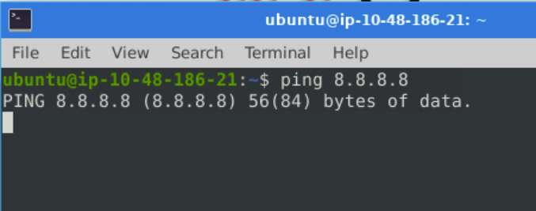
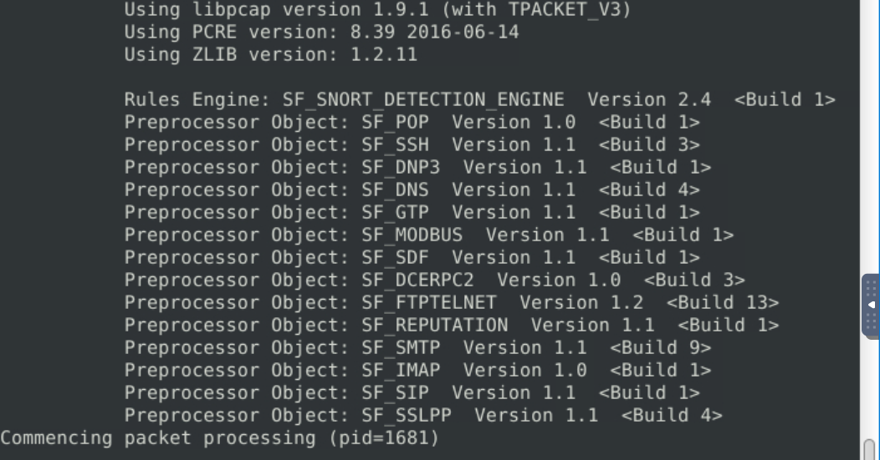

RESULT

Thus, Snort IDS/IPS was successfully configured on the TryHackMe platform to detect and prevent real-time network threats.

